INTERNSHIP REPORT ON

Cancer Genomics: Mutational Signature Comparison Across Two Cancer Types Using Public TCGA Data
(Genomic and NGS Internship)
Submitted By: Anupama Pathak
Shri Ramswaroop Memorial University


Submitted To: H.S Prithvi (mentor)


Internship Duration: 7 Weeks
Submission Date: 27th June

ACKNOWLEDGEMENT
I am extremely thankful to BioTechTrek for giving me this opportunity to intern in the field of Genomics and Bioinformatics. It was an immense learning experience where my understanding of Cancer Genomics, Mutational Signatures, and Computational tools used in the latest biological research strengthened significantly. I express my profound thanks to Ms. H.S. Prithvi, my mentor, for her consistent supervision, motivation, and the provision of technical guidance for the successful completion of my project entitled "Cancer Genomics: Mutational Signature Comparison Across Two Cancer Types Using Public TCGA Data". Her valuable mentorship not only helped in completing the project successfully but also helped enhance my understanding in Cancer Genomics and Bioinformatics.
I’m equally grateful to Mr. Dhruv Jain, Founder of BioTechTrek for his vision to provide the students a great platform for them to learn the up and coming technology and the opportunity to be engaged in real research oriented projects within biotechnology and bioinformatics.
Lastly, I would like to thank Shri Ramswaroop Memorial University and all faculty members for their motivation and support towards the completion of my degree. And of course my family and friends for being there in all possible ways that I can define and beyond. Thank you all.
Anupama Pathak
Genomic and NGS Internship
BioTechTrek

TABLE OF CONTENTS
Sr. No. | Title | Page No.
1 | Introduction | 1-101
2 | Tools and Software Used | 11-12
3 | General Workflow of NGS | 13-14
4 | Project Work | 15-17
5 | Project Workflow and Methodology | 18- 23
6 | Results and Discussion | 24-29
7 | Biological Interpretation | 30
8 | Skilled Gained | 31
9 | Challenges Faced and Solutions | 32
10 | Conclusion | 33
11 | Reference | 34-35

LIST OF FIGURES

Sr. No. | Title | Page No.
Figure 5.1 | Image of Project Directory | 18
Figure 6.1.1 | LUAD Mutation Summary Plot | 24
Figure 6.1.2 | COAD Mutation Summary Plot | 24
Figure 6.2.1 | LAUD Gene Summary | 25
Figure 6.2.2 | COAD Gene Summary | 25
Figure 6.3.1 | LAUD Oncoplot | 26
Figure 6.3.2 | COAD Oncoplot | 26
Figure 6.4.1 | Frequently Mutated Genes in COAD and LAUD | 26
Figure 6.4.2 | Top Differentially Mutated Genes | 27
Figure 6.4.3 | Significant Differentially Mutated Genes | 27
Figure 6.5.1.a | LAUD SBS96 Signature Plot | 28
Figure 6.5.1.b | LUAD Signature Activity Plot | 28
Figure 6.5.2.a | COAD SBS96 Signature Plot | 28
Figure 6.5.2.b | COAD Signature Activity Plot | 29

LIST OF TABLES

Sr. No. | Title | Page No.
Table 2.1 | Tools and their Function | 12
Table 4.3.1 | Cancer Types and its number of Samples | 16
Table 4.3.2 | Software Used and its Purpose | 16
Table 9.1 | Challenges and Solutions Implemented | 32

LIST OF FLOWCHARTS

Sr. No. | Title | Page No.
Flowchart 3.1 | Framework of NGS Pipeline | 14
Flowchart 5.1 | Actual Workflow of the Project | 22-23

1. INTRODUCTION
1.1 About the organisation
BioTechTrek is an education and research organization with the vision to inculcate, expand knowledge and expertise in areas like Biotechnology, Bioinformatics, Genomics, Computational Biology, Data Science etc. In students, research community and in professionals and individuals aspire to work in these domains. We aim to foster these competencies through Internships, Workshops, Training Programs and Project based learning to acquire hands-on experience on the modern Biological research methodologies and Computing Tools. The present era is characterized by dramatic progress in biological sciences, ever increasing influx of biological data, and consequent growing need of people with biological and computational competencies. BioTechTrek offers structured learning programs in these subjects covering both theoretical foundations and applied aspects.
Under our Internship Programs you’ll experience hands-on research using cutting-edge biological data and computational tools applied for biological/biomedical research. Our Learning philosophy is to promote learning through experimentation and the development of problem solving skills. We endeavour to inculcate self-learning skill and impart the ability to acquire new skills and knowledge. Students on completing internships, workshop or training program with BioTechTrek should be proficient enough to analyses and interpret biological data and know the applications of Bioinformatics for a research setting.
Learning approach includes biological and computing tools and techniques. Inter-disciplinary approach integrates the biological and computer Science topics together with data analysis in order to understand the system under biological perspectives using a computational framework
Main Areas of Work
Here are some of the primary domains of modern biotechnology and computational biology in which BioTechTrek operates: Genomics and Next-Generation Sequencing (NGS) - Bioinformatics covers analysis of next-generation sequencing data, mutation detection, sequence alignment, variant detection and interpretation of genome sequences. Students are trained in applying next-gen genomics techniques for understanding genetic disorders, common complex disease, cancer biology and evolutionary history. Bioinformatics and computational biology - The blend of computational biology, computer science and biology to identify and analyse common features of biology in datasets.bio.inc organisation teaches students how to use modern computation biology tools, software, algorithms, databases and languages like python and R for biology data analysis.
Students gain exposure of data handling and computation and biological data science analysis skills to learn pattern and significance out of such datasets.
Cancer genomics - A specialized study of how and why individuals can develop cancer; that cancer itself comprises many genetically driven sub diseases; and that each such diseases could be “smartly” treated using specific drugs. The organisation provides students with opportunity in order to learn how genome of cancer patients can analysed in order to reveal cancer drivers, genomic signature of cancer diseases and to visualize and interpret cancer genomic data available in databases (for example; the TCGA database). Transcriptomics and Gene Expression Analysis - Introduction into transcriptomic studies- which analyse all of the RNA produced in an organism. Information gathered can be useful in for understanding regulation of gene expression, gene functions, disease mechanisms etc.
Data science and Machine Learning applications in biology - Promoting the use of data science and artificial intelligence for solving biology problems such as prediction and classification problems for disease identification or other problems.
Research Training and Scientific Communication skills - Aside from technology training, organisation will assist learners improve in researching methods, practice writing and presentations of science, data and publications evaluation and critical reading.
Importance
As the amount of data generated through technologies like Next-Generation Sequencing (NGS) and other innovative technological methods of data generation in life science continues to rise at exponential rate, so has the significance of bioinformatics. It is now simply impossible to analyze vast sets of biologically related data using traditional approaches, highlighting need for computational methods to identify the trends within them. BioTechTrek contributes to the progress and further popularization of education in biotechnology and bioinformatics by enabling young adults with practical skills needed to perform computer analysis and interpretations of biological data in real settings and to conduct computational investigations in real labs.
As part of our initiatives students get an opportunity to familiarize with the state-of-the-art research methodologies and to learn the essential skills useful in academia and in industry.
Students with the opportunities to participate in real research projects in BioTechTrek have a unique advantage over their peers. By exposing them to real datasets and real scientific tools, we foster not only critical analytical and computational skills, but also the desire for exploration. By participating in programs, aimed at providing them with the skills necessary to be contributing citizens to important fields like precision medicine, drug discovery, genomics, health care analytics and biomedical research, we cultivate future professional.
1.2 About the Internship
The internship was held at BioTechTrek for 7 weeks in online mode. It was a training program focused on introducing the principles of Cancer Genomics, Bioinformatics, and Computational Biology by adopting a project-based learning approach that uses the hands-on analysis of biological data to gain practical insights.
The primary goal of this internship was to comprehend the usage of bioinformatics tools, and computational methods for exploring cancer genomic datasets. Through the training program, the interns learned about concepts on, mutational signatures, genomics, somatic mutations, interpretation of biological data, as well as cancer genomics research.
My project in this internship was "Cancer Genomics: Mutational Signature Comparison Across Two Cancer Types Using Public TCGA Data" which analyzed publicly available TCGA datasets from Lung Adenocarcinoma (LUAD) and Colon Adenocarcinoma (COAD) cancer datasets for mutation signature comparisons using R, Python, maftools, and SigProfilerExtractor for mutation analyses, comparisons, and signature estimation.
Working online allowed flexibility while still maintaining regular communication with my mentor who provided continuous support through training, project related discussions and the technical assistance that was regularly available. The training aimed to balance the understanding of fundamentals with their application in the real world thus the hands on work done on large biological datasets and understanding of biological interpretations during the training program.
Duration of Internship
The internship lasted for 7 weeks, with both lectures-based and project based activities which were carried out throughout the Internship. Every part of the Internship looked at specific elements of analysing and interpreting cancer genomics; data procurement; analysing mutations and visualising; Mutational Signature Identification; and biologically interpreting results. The duration of 7 weeks was enough to have a good understanding of an entire bioinformatics pipeline, from collecting the data to preparing reports.
Mode of Internship
This Internship was undertaken in an online mode with complete access to learning material, software, datasets, and mentorship over virtual mode. The online internship programme enabled the students with a flexibility of learning in the industry and introduced the latest Computational tool in research. Even in the virtual setup, importance has been laid down upon a hands-on learning approach that could be delivered through individual projects that the trainees were allocated as guided by their mentors, software demos and periodic one-on-one interactions.
Objectives of the Training
The primary objectives of the internship were:
- To understand the fundamental concepts of cancer genomics and bioinformatics.
- To gain practical experience in analysing cancer mutation datasets obtained from public repositories.
- To learn the structure and interpretation of Mutation Annotation Format (MAF) files.
- To perform mutation analysis using the maftools package in R.
- To identify and compare frequently mutated genes in different cancer types.
- To generate and interpret genomic visualizations such as oncoplots and mutation summary plots.
- To understand the concept of mutational signatures and their biological significance.
- To extract mutational signatures using SigProfilerExtractor.
- To compare mutational patterns between LUAD and COAD using computational approaches.
- To develop skills in biological data interpretation and scientific reporting.
- To gain exposure to research methodologies commonly used in genomics and precision medicine studies.
  - Introduction to Next-Generation Sequencing (NGS)
What is Next-Generation Sequencing (NGS)?
Next-Generation Sequencing (NGS) describes a set of high-throughput, advanced technologies used for massive, simultaneous sequencing of DNA fragments. Compared to traditional Sanger sequencing (which reads one DNA fragment at a time), NGS technologies offer high speed, higher capacity and greater cost-effectiveness for large scale analyses of genomic, exomic, transcriptomic or epigenomic samples. NGS applications have dramatically enhanced biological and medical research by facilitating research of complete genomes, exomes, transcriptomes or epigenomes, and these resulting data streams can be analyzed computationally through bioinformatics to detect mutations, genetic variations, gene expression changes, and to find biomarkers that are linked to disease states.
A typical NGS workflow include sample preparation, library construction, sequencing, data generation and bioinformatics analysis.
The sequencing step generates millions of simultaneous reads from all millions of DNA fragments at hand, resulting into vast data which carry genetic information. NGS has been one of the most important developments in genomics and biology since the availability of its early applications for large scale studies, and it is widely utilized by scientists to address complex biological research questions.
Applications of NGS
NGS (Next Generation Sequencing) have countless uses, which span over biological, medical, agricultural as well as biomedical science, some important applications are as follows.
WHOLE GENOME SEQUENCING Whole Genome Sequencing or WGS is a comprehensive study of sequencing an organism's genome. These types of studies also provide information about those alterations, that occurs at the genetic or genomic level and is linked to an illness.
WHOLE EXOME SEQUENCING Whole Exome Sequencing or WES determines the sequence all exons (coding region) on of our genomes together. Because of that more than 85% of all known disease-causing mutations occur in coding regions that are well-analyzed by whole exome sequencing.
RNA SEQUENCING RNA sequencing, sometimes called as whole transcriptome shotgun sequencing is applied to determine amount of RNA, in a biological sample at a specific time. RNA sequencing analysis is the process that gives a quantitative measure of an RNA target sequence and that provides a snapshot of all of that sequences that have been expressed and processed within the cells, at a certain point in the life cycle.
CANCER GENOMICS Researchers apply the knowledge gained from cancer whole genome sequencing (also referred as cancer sequencing, tumor profiling, or genomic oncology) to learn more about tumor development, to identify potential therapeutic targets and in some cases to help physicians make better treatment decisions for patients with cancer.
METAGENOMICS Metagenomic is the genetic or DNA sequence data acquired directly from environmental samples and, in the case of humans. It is used widely in research on our gut Microbiome or for analysing a given infection.
CLINICAL DIAGNOSTICS Clinical genetic testing that utilize NGS technologies have a growing number of uses for: The diagnosis of previously uncharacterized, or undiagnosed, genetic disorders. The confirmation of genetic disorders identified through other methods. Prenatal screening for genetic diseases. Determining the likely cause of an inherited disorder.
DRUG DISCOVERY AND DEVELOPMENT Pharmaceutical companies have been early and enthusiastically adopters of next generation sequencing, using it for a multitude of tasks ranging from drug candidate identification and validation and to drug repurposing to understanding biological responses to treatments.
Importance of NGS in Genomics
NGS, which is shorthand for “next-generation sequencing”, has revolutionized the fields of genetics and genomic research because of its capacity for performing genetically analyses on an massive scale. Compared to “old school” sequencing approaches that were both costly and labour intensive, NGS can yield vast amounts of genomic data quickly and comparatively inexpensively. By performing high-throughput genomic analysis of either genomic or the less comprehensive xeronic or even targeting analyses of other parts of the genome, these technologies provide a “birds-eye” view of an organism’s complete genome sequence or specific parts of interest.
NGS has the capacity to capture different types of genomic variation including small variations like single nucleotide variants (SNVs, mutations in a single nucleotide) and inserting/deleting small numbers of base pair “letters” (short indels), copy number variants (CNVs), which represent large DNA insertions and deletions, and structural variants (which represent larger scale changes in the organization of the genome, like chromosomal rearrangements). This makes it a particularly powerful tool for studying evolutionary histories, genetic diversity, human and disease susceptibility.
NGS has dramatically sped up the genomic research. The application has enable major ongoing projects like The Cancer Genome Atlas (TCGA), which catalogues cancer genome sequencing results into a readily accessible publicly available dataset that scientists worldwide can access for use in biomedical research. There has been a plethora of publications published using the large-scale population genome data including studies investigating genome diversity between populations, and associations of genes and genomic variations with different diseases.
In cancer, it has made possible the identification of tumor-causing mutations that contribute to tumor onset and progression and the comprehensive profiling of cancer mutational spectrum.
These analyses can reveal detailed understanding of cancer biology and also aid the development of personalized, or “precision,” cancer treatments that use NGS and genomic analysis information to select patients for treatment with targeted drug therapy and guide other therapeutic choices.

NGS and Precision Medicine
Another promising area where NGS is playing a significant role is the advent of precision medicine, which aims to tailor the medical treatment based on an individual’s genetic make-up, life-style, environment. The sequencing data acquired through the NGS technology serves as a data bank to identify variations that may be associated with the pathogenesis of certain disorders. Through these genetically based, highly personalized treatments, healthcare providers aim to improve disease outcomes while reducing the instances of adverse responses.
For example, in the field of oncology, sequencing technologies can identify specific actionable mutations for specific therapies.
Based on an individual’s specific tumor genomics, personalized treatments can be administered to Cancer patients that are more efficient and better tolerated. Apart from therapeutics, NGS can also be used for biomarker discovery. As the cost of sequencing reduces and sequencing technology continues to evolve with greater capabilities, NGS is going to be critical for disease prevention, diagnostics and to truly deliver personalized healthcare. In conclusion, Next Generation Sequencing has indeed transformed genomics, allowing us to perform large-scale sequencing studies that helped us gain tremendous insight into various biological systems.
The uses of NGS are far and wide, ranging from research, diagnostics, oncology genomics and to enabling precision medicine
1.4 Introduction to Bioinformatics
Bioinformatics is the study of data using an integrated approach that involves biology, computing, mathematical and statistics to make sense of biology related information. With the emergence of technologies such as next-generation sequencing that churn out massive data sets and require automated analysis, computing sciences are becoming integral part of every biological research. Bioinformatics involves all the processes required to carry out sequencing, finding patterns in genes (gene annotation), mutations (mutation discovery), genes expressions (gene expression) and predicting protein structure as well as building models (system biology).
In essence, Bioinformatics utilizes this information extracted from biological systems in a form of data so that relevant inferences can be derived and contribute to discovery of newer findings for use in science that would include genomics, molecular biology, medicine, biotech, as well as system biology applications.
Bioinformatics has already revolutionized biology because all of information and data associated in it require computation and analysis for further development. With advances in the sequencing technology, the usage of Bioinformatics for analysis of enormous amounts of DNA or RNA sequences or whole genomic sequences to extract biologically important data has also increased. The applications of Bioinformatics for medical purposes is increasing. Bioinformatics helps doctors diagnose the diseases, discover and develop medicine for treatment, improve diagnosis or treatment of cancer and even develop new treatments for cancer based on the information generated about cancer DNA. It also leads the way to precision medicine.

1.5 Cancer Genomics
Cancer genomics is the the analysis of genetic changes involved in the establishment and progression of cancer. The acquisition of genetic changes leads to altered gene function, which promote abnormal cell proliferation and tumor growth, and these changes accumulate over time to generate cancer. Molecular and functional analyses of cancer genomes by cancer genomics identify the underlying processes of development and provide information on their significance and on genes that drive tumor formation and progression. Identification of mutations driving cancer, targets for therapy, the origin of mutations driving cancer, and markers for diagnosis, prognosis, and monitoring for treatment will require cancer genomics technology.
1.6 Somatic Mutations and Cancer
Somatic mutations are acquired, and they only take place in non-reproductive cells at the cellular level. This means that these mutations do not pass down through generations like inherited mutations; it instead accumulates over an individual’s lifetime as a result of exposure to the environment and external sources like chemicals, radiation, errors in DNA duplication or flaws in DNA repair processes.
Most are insignificant but they happen to cause an impact on the cells’ genes that govern their multiplication and demise and on genome stabilization, consequently driving cancerous advancement and tumor growth and the proliferation process; thereby enabling tumor initiating events as well as tumor metastasis and growth to occur. Somatic mutations help explain this disease progression.
1.7 Mutational Signatures
Mutational signatures are characteristic patterns of mutations generated by specific biological processes or environmental exposures. Each mutational process leaves a distinct molecular fingerprint within the genome that can be identified through computational analysis.
These signatures provide valuable information about the underlying causes of DNA damage and mutation accumulation. Common mutational processes include aging, tobacco smoking, ultraviolet radiation exposure, APOBEC enzyme activity, and defects in DNA repair pathways.
The analysis of mutational signatures enables researchers to investigate cancer etiology, understand tumor evolution, and identify mechanisms contributing to genomic instability. As a result, mutational signature analysis has become an important area of cancer genomics research.
1.8 The Cancer Genome Atlas (TCGA)
The Cancer Genome Atlas is one of the largest collections of publicly available cancer genomes. It was initiated to build molecular portraits of all major human cancer types through integrated analyses of genomic and clinical information obtained from tens of thousands of cancer patient samples. The TCGA database encompasses datasets on genetic and epigenetic alternations, such as somatic mutations, gene expression, DNA methylation, copy number variations and also clinical data. The public access to these datasets have driven significant advancements in understanding cancer biology in terms of enabling genome wide comparative studies between cancer types, as well as allowing new approaches toward developing computational cancer analysis algorithms and new diagnostic and therapeutic targets.
1.9 Introduction to LUAD and COAD
Colon Adenocarcinoma (COAD) and Lung Adenocarcinoma (LUAD) are two of the best studied cancers in cancer genomics. LUAD is the most common subtype of non-small cell lung cancer and is commonly driven by alterations in genes altered by smoking; however, other genetic drivers have also been observed. Lung cancer shows tremendous genomic diversity and many LUAD genomes contain multiple mutations in a variety of cancer driver genes to affect tumor initiation, development and maintenance. COAD is a leading subtype of colon cancer and are commonly associated with mutations impacting signaling, DNA repair and overall genomic stability.
Some COADs are characterized by microsatellite instability and extremely high mutational loads due to loss-of-function of genes involved in DNA repair. The Comparison of LUAD and COAD is a system that allows to examine how mutations occur differentially in various cancers.
1.10 Tumor Mutational Burden (TMB)
Tumor Mutational Burden (TMB) is defined as the total count of somatic mutations harboured within a tumor’s genome. In clinical practice, TMB is typically expressed in terms of the number of mutations per megabase (Mut/Mb) of genomic material. The rationale behind the development and clinical application of TMB is its potential role in predicting responses to specific therapies-mainly certain immunotherapy strategies-given that tumors with high TMB frequently possess elevated levels of tumor-specific neoantigens capable of being recognized by T cells.
1.11 Oncoplots
Oncoplots are graphs for presenting mutational profiles of different tumour samples. This is to give a clear and precise view of mutation status for genes vs tumour samples. Each of the colours signifies a type of mutation and can be used to discover recurring mutated gene, mutually exclusive pattern, mutational diversity. Oncoplot is commonly utilised by researchers in cancer genomics to have an interpretation with the massive mutation data.
In this project, oncoplots have been constructed by utilising maftools package in R to explore the difference in mutation patterns between LUAD and COAD samples.
1.12 Mutation Frequency Analysis
To perform Mutation Frequency Analysis, we want to look for genes in a cancer data set that occur in a particular mutation pattern. Frequent mutate genes are also in fact key genes which play a role in genesis of cancer, which may turn out to be key markers and targets for treatment. Through the frequency, researchers can detect molecular properties between the cancer samples and determine the mutation rate and biological mechanisms.

1.13 Comparative Mutation Analysis
Mutation heterogeneity of cancers 11.4Comparative mutation analysis Comparative mutation analysis allows researchers to study differences in mutation signatures between cancer types. Researchers are able to apply different statistical tests on observed frequencies differences to see if there is significant difference between them. The knowledge obtained from Comparative mutation analysis assist the research of cancer-driver genes, molecular differences and biological process and pathway related on tumor growth and evolution. In this project, Comparative mutation analysis was applied in order to find genes which are differ significantly between LUAD and COAD on mutated signature.
  - COSMIC Mutational Signatures
COSMIC-the Catalogue of Somatic Mutations in Cancer-is the premier source of cancer mutations and the world-renowned platform for researching mutational signatures. The team also curates a repository of reference mutational signatures that represent known biological and environmental exposures. Each of these reference signatures have their own individual designation (e.g. SBS1, SBS4, SBS5, SBS13, SBS15, SBS21) and they have been assigned to biological or environmental agents, such as aging, smoking, APOBEC, MMR deficiency and proofreading-defective DNA polymerases.
In turn, researchers can match the mutational signatures derived from patient tumors with COSMIC signatures to understand the drivers of mutagenesis that promote cancer development.
1.15 SigProfilerExtractor
SigProfilerExtractor: Tools for Mutational Signature Identification Software SigProfilerExtractor is a tool designed for extracting and characterizing mutational signatures. It analyses a somatic mutation catalogue and utilizes a method such as Non-negative Matrix Factorization (NMF) to extract de novo mutational signatures. SigProfilerExtractor extracts, compares and visualizes the resulting signatures as a signature plot and activity plots which can be used to analyze and understand the mutagenic processes. The analysis helped in inferring mutational patterns contributing to the build up of tumor mutations of the LUAD and COAD sets, respectively in the current project.
1.16 Cancer Genomics and Precision Medicine
Precision medicine uses genetic information from an individual to personalize treatments and prevent diseases. Cancer genomics plays an integral role in precision medicine because genomic sequencing can reveal the molecular drivers of cancer growth, response to targeted drugs and survival outcomes. In clinical settings, it can reveal targetable mutations.
Clinicians can tailor treatment plans to specific tumor molecular profiles for a higher likelihood of successful outcomes, while simultaneously minimizing potentially debilitating side effects.
The application of Cancer Genomics in disease monitoring, Biomarker development and Prognostic predictions will see its impact amplified as sequencing technology keeps advancing and its applications for the overall treatment landscape grow.

1.17 Objectives of the Present Study
The aims of the study were to investigate and compare the mutational signatures and patterns of LUAD and COAD based on the publicly available data from the TCGA.
The specific objectives for the study were:
- To understand the principles of cancer genomics and mutational signature analysis.
- To obtain and analyse LAUD and COAD mutation datasets from TCGA.
- To identify frequently mutated genes in both cancer types.
- To visualize mutation distributions using oncoplots and mutation summary plots.
- To perform comparative mutation analysis using bioinformatics tools.
- To extract mutational signatures using SigProfilerExtractor.
- To compare extracted signatures with COSMIC reference signatures.
- To interpret the biological significance of identified mutations and mutational signatures.
- To investigate molecular differences between LAUD and COAD.
- To gain practical experience in bioinformatics workflows, genomic data analysis, and scientific reporting.

- TOOLS AND SOFTWARE USED
Operating system: Linux/Ubuntu/Windows PowerShell
NGS TOOLS:
FastQC- FastQC (Fast Quality Control) FastQC is an open source tool to do initial quality control of raw sequence data. It checks various properties of the sequences like quality scores, GC content, levels of sequence duplication, presence of adapter contamination, over-representation of certain motifs etc.
MultiQC- MultiQC: Quality Control Reporting Made Simple MultiQC is used to consolidate reports produced by multiple bioinformatics tools into a single report, useful for summarizing all quality control data generated by different steps of an analysis and making easy comparisons between samples.
Trimmomatic - The Trimmomatic program (Bolger et al., 2014) is a well-known preprocessing software tool for removing unwanted sequences such as adapter sequences. Other filtering capabilities allow removing low-quality base positions within read and removing low-quality reads. The cleaned reads are subsequently used for subsequent steps such as sequence alignments and variants calls.
BWA (Burrows–Wheeler Aligner)- BWA (Burrows-Wheeler Aligner) This popular tool aligns short DNA sequencing reads to a reference genome using the Burrows-Wheeler Transform, providing fast and accurate alignments. Accurate read alignment is fundamental to effective variant detection, making BWA a cornerstone of most NGS analysis workflows.
SAMtools- SAMtools is an essential software tool for reading and manipulating SAM/BAM alignment files that contain sequencing information and its alignments in FASTA or FASTQ format. This software can sort, compress, view, access and manipulate sequence files. SAMtools helps sort and indexes SAM alignment file format to be accessed as the next stage, such as for variant calling.
Picard- Picard are a set of Java-based command-line tools for manipulating next-generation sequencing data that perform various functions such as sorting BAM files, marking duplicates, validating alignment files and collecting sequencing metrics. Marking duplicates helps minimize false positives from PCR amplification during library preparation.
GATK (Genome Analysis Toolkit)- A Complete Toolkit for Variant Discovery GATK is a comprehensive set of command-line tools for variant discovery from NGS data. Developed by the Broad Institute, GATK has become the industry standard for variant calling of SNVs and short indel variants and includes base quality score recalibration, variant calling and variant filtering tools, and other pre-processing tools.
ANNOVAR- ANNOVAR is a functional annotation tool designed to facilitate the interpretation of genetic variation found from any high-throughput sequencing study. The program annotates variants according to features in their affected genes including amino acid change, clinical associations (such as any catalogue of disease variants like Clinvar), population-level variant frequency ( dbSNP, Exac, gnomAD, etc) and whether they lie within regions known to impact variation( such as UTRs, exons, introns and regulatory regions). The software outputs comprehensive and convenient annotation reports enabling researchers to determine the potential biological and clinical implications of the identified variations.

Table 2.1: Tools and their Function
Tool | Primary Function
FastQC | Quality assessment of raw sequencing reads.
MultiQC | Combines quality reports from multiple samples into a single report.
Trimmomatic | Removes adaptors and trims low- quality sequencing reads.
BWA | Aligns sequencing reads to a reference genome.
SAMtools | Processes, sorts, indexes, and manages SAM/BAM files.
Picard | Marks duplicate reads and perform BAM file processing.
GATK | Variant calling and genomic data processing.
ANNOVAR | Functional annotation and interpretation of genetic variants.

Other Tools:
R Programming Language- R is an open source programming language and a software environment developed for statistical computing, analysis and visualization of biological data. In the field of Bioinformatics, the R software comes equipped with a broad number of specialized packages for the analysis of genomic and biological data. Throughout the project, R was used to perform mutation analysis, to create oncoplots, to locate the commonly mutated genes as well as comparing mutational patterns by the maftools package.
Python- Python is a comprehensive high-level general-purpose programming language applied broadly across bioinformatics, data science and machine learning. Its vast number of libraries facilitate manipulation and analysis of bioinformatic datasets. SigProfilerExtractor was applied on the respective datasets to extract mutational signatures and plots showing signature contributions, as well as signatures contribution per sample to produce signatures and activity plots for LUAD and COAD dataset.
Microsoft Excel- This project involved using Microsoft Excel, an application for collecting, organizing, managing, analysing, and manipulating tabular data to be represented in columns. Various tools available in MS Excel like sorting, filtering, calculation, and chart creation helps in manipulating and presenting data efficiently. MS Excel was extensively used to look through CSV output files, compare mutation rates and to store and arrange the results of the analysis as tables to be used for the internship report.
GitHub- GitHub is an online-hosting platform for Git based projects. It allows individuals to use code repository for sharing and collaboratively maintain the version control of software. We have utilized GitHub at our internship for finding project materials, Downloading scripts, and sharing code/Scripts and project workflows to improve reproducibility, collaborate together with team and many more.

- GENERAL WORKFLOW OF NGS

The fundamental NGS Workflow Next-Generation Sequencing (NGS) workflow follows a number of laboratory and bioinformatics procedures transforming samples into a genome based product. The individual steps facilitate accurate sequencing data and the following biological data output.

Step.1 Data Collection: Collect biological samples (such as blood, tissues or cells grown in cell cultures). Extract high quality DNA or RNA from the sample for sequencing.
Step.2 Library Preparation: The captured DNA or RNA molecules are cut into smaller fragments by an enzyme, and a specially designed adapters are added by ligase to each end of those fragments, to create the sequencing library.
Step.3 Next-Generation Sequencing: Libraries Prepared Libraries prepared with the kits are deposited to an NGS platform (e.g., Illumina) to sequence many millions of DNA molecules in parallel and produce raw sequencing reads.
Step.4 Quality Control(FastQC): To measure raw read quality use the FastQC program. Examine base quality scores, GC content, length of reads, sequence data quality and contamination by adapter.
Step.5 Quality Report Generation(MultiQC): Combining results from FastQC in multiple samples. Using MultiQC.
Step.6 Read Trimming( Trimmomatic): High-quality reads generated through low-quality bases and adapter sequences removed using Trimmomatic so the clean reads can be used for downstream analysis.
Step.7 Sequence Alignment (BWA): Aligned with respect to reference genome: After cleaning reads, they are aligned with reference genome via BWA (Burrows-Wheeler Aligner). Sam/bam output files.
Step.8 Alignment Processing (SAMtools and Picard): After that, samtools software is used for ordering and indexing the alignment files, and Picard is used for filtering out and marking duplicated reads for more precise variant calling.
Step.9 Variant Calling (GATK): Identify genetic variation with GATK - The GATK framework uses read comparisons to identify SNVs and Indels, with all aligned reads from individuals compared against the reference genome.
Step.10 Variant Annotation (ANNOVAR): The identified variants are annotated using ANNOVAR to report on affected gene(s), protein change(s), disease relationship, and recorded in genomic datasets.
Step.11 Biological Interpretation: Annotated variants can then be screened and studied to detect meaningful mutations and relevant biological factors, including candidate genes, diagnostic markers, and new therapeutic targets.

Sample Collection
DNA/RNA Extraction
Library Preparation
Next Gen Sequencing
FastQC Files
FastQC
MultiQC
Trimmomatic
BWA Alignment
SAMtools(Sort & Index)
Picard(Mark Duplicates)
GATK Variant Calling
ANNOVAR Variant Annotation
Biological Interpretation
Flow-chart 3.1: Framework of NGS Pipeline

4. PROJECT WORK
4.1 PROJECT TITLE: Cancer Genomics: Mutational Signature Comparison Across Two Cancer Types Using Public TCGA Data
Problem: Cancers occur as a result of acquisition of numerous somatic mutations resulting from a number of biological and environment driven mutational process. These mutational processes result in the leaves of molecular marks or signatures, which may inform the mechanisms of cancer genesis. Although studies that have explored mutational signatures of cancers across large pan-cancer sets or within a particular type of cancer have existed for many years, a concentrated open-source comparative analysis of Lung Adenocarcinoma (LUAD) and Colon Adenocarcinoma (COAD) at the cohort level does not readily exist.
Without this type of comparative studies we are still struggling with identifying mutually occurring mutational processes within these cancers or whether these processes are specific to one another. This is why, the purpose of this project was to make an extensive analysis of mutational signatures and the mutation patterns of LUAD and COAD from data readily available in the public domain TCGA dataset.
4.2 Objectives of the Project
The main objectives of this project are:
- To download somatic mutation MAF (Mutation Annotation Format) files for LUAD and COAD from The Cancer Genome Atlas (TCGA) database.
- To process and analyse mutation data using the maftools package in R.
- To identify the most frequently mutated genes in both cancer types.
- To generate mutation visualizations, including oncoplots and mutation summary plots.
- To perform comparative mutation analysis between LUAD and COAD using mafCompare().
- To extract mutational signatures using SigProfilerExtractor.
- To compare the extracted signatures with COSMIC SBS reference signatures.
- To compare the mutational signature profiles of LUAD and COAD and identify shared and cancer-specific signatures.
- To biologically interpret the identified mutations and mutational signatures, including age-related, smoking-related, APOBEC-associated, and DNA mismatch repair-associated processes.
- To understand the molecular differences between LUAD and COAD using public TCGA genomic data.
4.3 Dataset Description
Data Source: All mutations in TCGA, can be easily accessed from The Cancer Genome Atlas (TCGA) via the Genomic Data Commons (GDC) Data Portal . TCGA is the leading public cancer genomics resource providing high-quality, well-annotated genomic and clinical data sets for a number of cancer types . In this study, MAF format somatic mutation data sets for Lung Adenocarcinoma (LUAD) and Colon Adenocarcinoma (COAD) have been acquired.
Cancer Types and Number of Samples:
The study focused on two cancer types available in the TCGA database:
Table 4.3.1: Cancer Types and its number of Samples
Cancer Type | TCGA Project | Number of Samples*
Lung Adenocarcinoma | TCGA-LUAD | 585
Colon Adenocarcinoma | TCGA-COAD | 399

Sequencing Platform: Mutation data for all tumors was acquired from the Cancer Genome Atlas (TCGA) where it was prepared using Next-Generation Sequencing (NGS) technology, mostly Whole Exome Sequencing (WES). Whole Exome Sequencing covers primarily the areas of the genome which code for proteins, the areas within the genome where most mutations which can lead to cancer can be detected. No lab sequencing took place as the data used was publicly available from TCGA.
Data Format: The datasets download in Mutation Annotation Format (MAF). It's a flat file format for storing information about somatic mutations called cancer genome, and also the format that be loaded directly to maftools. Information about these mutations:
- HUGO Gene Symbol
- Chromosome Number
- Genomic Coordinates
- Variant Classification
- Variant Type
- Reference and Alternate Alleles
- Protein Change
- Tumor Sample Barcode
- The MAF format is fully compatible with the maftools package in R, making it suitable for mutation analysis and visualization.
Data Analysis Platform:
The computational analysis of the downloaded datasets was carried out using the following software and programming environments:
Table 4.3.2: Software Used and its Purpose
Software/Platform | Purpose
R Programming Language | Mutation analysis, gene summary, oncoplots, comparative mutation analysis using maftools
RStudio | Integrated Development Environment (IDE) used to execute R scripts
Windows PowerShell | Command-line interface used to execute Python commands
Python | Mutational signature extraction using SigProfilerExtractor
Microsoft Excel | Viewing, organizing, and comparing CSV output files
GitHub | Accessing project resources and managing project scripts

Dataset Utilization:
The LUAD and COAD mutation datasets were used to perform the following analyses:
- Import and process MAF files in R.
- Generate mutation summaries and identify frequently mutated genes.
- Create oncoplots to visualize mutation patterns.
- Perform comparative mutation analysis using mafCompare().
- Extract mutational signatures using SigProfilerExtractor.
- Compare extracted signatures with COSMIC SBS reference signatures.
- Interpret the biological significance of the identified mutations and mutational processes.

5 . PROJECT METHODOLOGY/ WORKFLOW

Step1 Downloading the Mutation Datasets from TCGA:
LUAD and COAD somatic mutation datasets were downloaded from the TCGA via the GDC Data Portal using the MAF format.
Platform used- Wb Browser( TCGA/GDC Data Portal)
Output- LAUD.maf and Coad.maf
Step2 Create Project Directory
A unique project sub-directory has been created which will contain both the input and output files as well as scripts files and plots.
Platform- Windows File Explorer
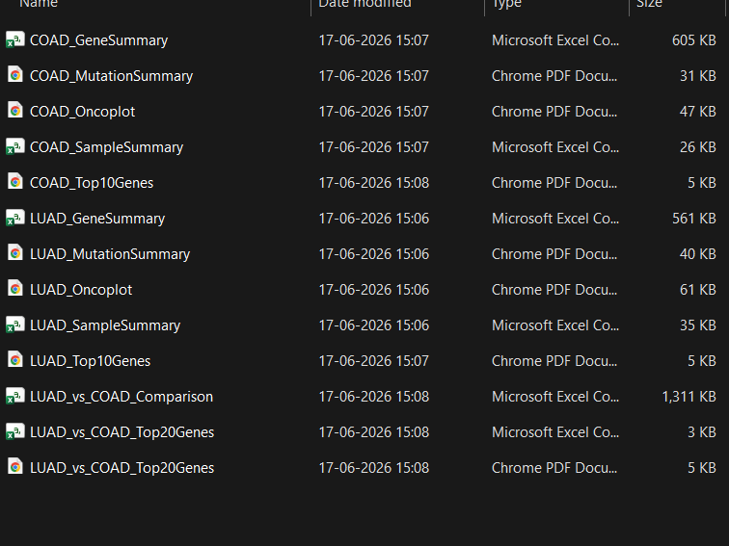
Figure 5.1 Image of Project Directory
Step3 Setting Up the Analysis Environment
Installed all the needed software and packages prior to begin with the analysis.
Platform- RStudio
</> R
If(!requireNamespace(“BiocManager”, quietly= TRUE)
Install.packages(“BiocManager)
BiocManager::install(“maftools”)
Load Package
Library(maftools)

Step4 Import LAUD and COAD MAF Files
The downloaded LAUD and COAD MAF files were imported into R using the
maftools packages.
Platform- RStudio
</> R
laud <- read.maf(“LAUD.maf”)
coad <- read.maf(“COAD.maf”)
Step5 Mutation Summary Analysis
Mutation summaries have been used to describe: the total number of mutations; the
Different classes of mutation; type of variation; sample statistics.
Platform- RStudio
</> R
getSampleSummary(laud)
getGeneSummary(laud)

getSampleSummary(coad)
getGeneSummary(coad)

Step6 Exporting Gene Summary
The gene summary tables were exported as CSV files for further analysis and documentation
</> R
write.csv(getGeneSummary(laud),
“LAUD_GeneSummary.csv”,
row.names = FALSE)
write.csv(getGeneSummary(coad),
“COAD_GeneSummary.csv”,
row.names = FALSE)

Step7 Generation of Oncoplots
We generate oncoplots to visualize the frequent genes and mutation pattern for LUAD and
COAD samples.
LAUD
</> R
pdf(“LAUD_Oncoplot.pdf”)
oncoplot (maf =laud, top10)
dev.off()
COAD
</> R
pdf(“COAD_Oncoplot.pdf”)
oncoplot (maf =coad, top10)
dev.off()
Step8 Mutation Summary Plot
The mutation summaries were created in order to observe mutation burdens, variant types,
and classifications of mutations.
</> R
pdf(“LAUD_Summary.pdf”)
plotmafSummary(maf = laud)
dev.off()

pdf(“COAD_Summary.pdf”)
plotmafSummary(maf = coad)
dev.off()
Step9 Comparative Mutation Analysis
Mutation frequencies between LAUD and COAD were compared using the
mafCompare()
</> R
comparison < - mafCompare(
m1 = laud,
m2 = coad,
m1Name = “LAUD”,
m2Name = “COAD”
)
Step10 Exporting Comparative Analysis Results
The comparative mutation analysis results were exported as a CSV file.
</> R
write.csv(
comparison$results,
“LAUD_VS_COAD_Comparison.csv “,
row . names =FALSE
)
Step11 Visualization of Differently Mutated Genes
The top significantly differentially mutated genes were visualised using a bar plat
</> R
Top20 <- head(
Comparison$results[
Order(comparison$results$adjPval),
],
20
)
pdf(“LAUD_VS_COAD_Top20Genes.pdf)

barplot(
-log10(top20$adjPval),
names.arg = top20$Hugo_Symbol,
las = 2
main= “Top Differentially Mutated Genes”
)
Dev.off()
Step12 Installing SigProfilerExtractor
The SigProfilerExtractor package was installed using Python
Platform- Windows PowerShell
</> Powershell
Pip install SigProfilerExtractor
Step13 Mutational Signature Extraction for LAUD and COAD
The LAUD and COAD mutation dataset was analysed using SigProfilerExtractor
Platform- Windows PowerShell
</> Python
from SigProfilerExtraction import sigpro as sig
sig.sigProfilerExtyractor(
input _type=”maf”,
output=”LAUD_Assignment”,
input_data= “LAUD.maf”,
reference_genome= “GRCh38”
)

</> Python
from SigProfilerExtraction import sigpro as sig
sig.sigProfilerExtyractor(
input _type=”maf”,
output=”COAD_Assignment”,
input_data= “COAD.maf”,
reference_genome= “GRCh38”
)

Step15 COSMIC Signature Assignment
SigProfilerExtractor automatically compared the extracted signatures with the COSMIC SBS reference signatures and generated
- SBS96 Signature Plots
- Signature Activity Plots
- COSMIC Assignment Results
- Signature Contribution Tables
Step16 Biological Interpretation
Underlying biological basis of LUAD and COAD by LUAD and COAD the observed mutations and mutational signature were elucidated The results were correlated with the established mutational signature of COSMIC to further explain the mechanism of the role aging, smoking, APOBEC activity, MMRd, and POLE associated mutations on pathogenesis.
TCGA (GDC Data Portal)
Download LUAD & COAD MAF Files
Install R Packages (maftools)
Import MAF Files into RStudio
Mutation Summary Analysis
Gene Summary Analysis
Generate Oncoplots
Generate Mutation Summary Plots
Comparative Mutation Analysis (mafCompare)
Export Comparison Results
Install SigProfilerExtractor
(Python via Windows PowerShell)
Extract Mutational Signatures
COSMIC Signature Assignment
Generate SBS96 & Activity Plots
Biological Interpretation
Flowchart 5.1: Actual Workflow of the Project

6. RESULTS AND DISCUSSION
This section reports the analysis outcomes in the comparative mutational feature of LUAD and COAD obtained through the TCGA public mutation data and performed using maftools in R and SigProfilerExtractor in Python. These analysis include the following plot of mutation summary, oncoplot of somatic mutations, comparative mutations between LUAD and COAD, as well as mutational signature plots.
6.1 Mutation Summary Analysis- The Mutation Summary table offers a bird’s-eye view into the genomic features of the MAF files obtained from the download. It presents the count of mutated genes, total number of variants, variety in mutation classification and types of mutations, mutation burden, and the genes that are mutated often. As with the COAD dataset, the MAF dataset for LUAD consisted of many missense mutation scattered across several genes; hence the diversity of mutated gene in LUAD dataset seemed very appealing.
As in COAD dataset, mutation count was high, however, differ much from MAF of COAD in terms of mutated frequency distribution across genes and mutations in genes.
Mutation Summary served as the primary quality check for the downloaded dataset and the first layer of comparison between the datasets.
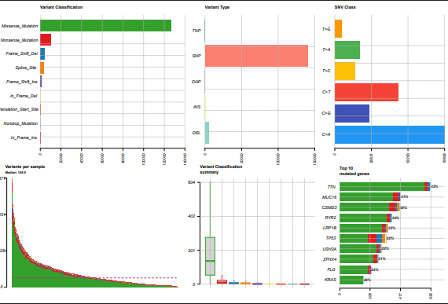
Figure 6.1.1: LUAD Mutation Summary Plot
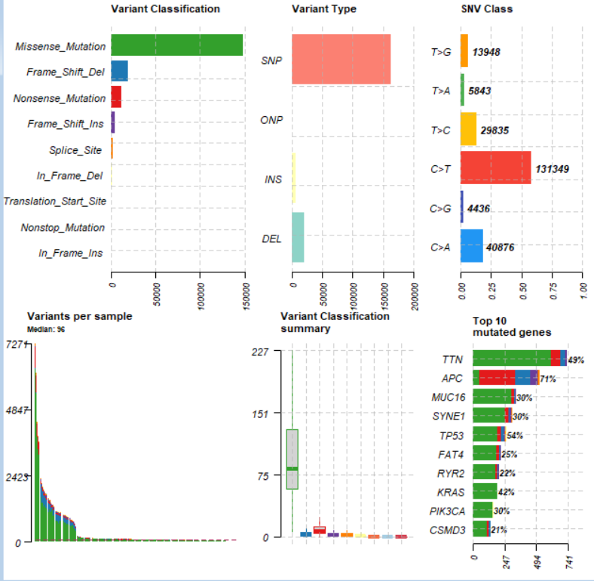
Figure 6.1.2: COAD Mutation Summary Plot
6.2 Frequently Mutated Genes- Gene summary analysis revealed that some genes were the most mutated in both types of cancer. For LUAD, there were TP53, KRAS, EGFR, KEAP1, STK11 and SMARCA4 gene identified with higher mutation frequency. For COAD, APC, TP53, KRAS, PIK3CA, FBXW7, RNF43 and SOX9 are listed as frequently mutated genes. Such discrepancies mean that these genes have different routes through tumorogenesis and are linked to both LUAD and COAD.
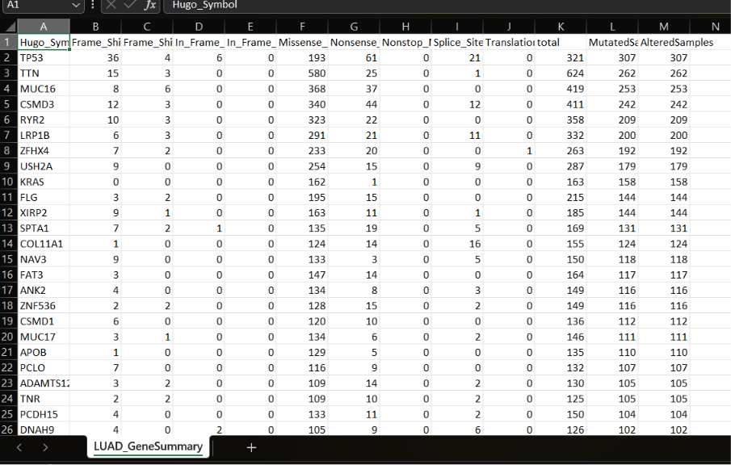
Figure 6.2.1: LUAD Gene Summary
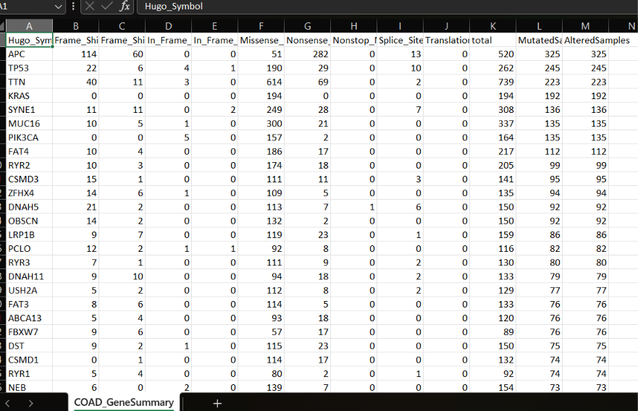
Figure 6.2.2: COAD Gene Summary

6.3 Oncoplot Analysis- Oncoplots of LUAD( lung adenocarcinoma) and COAD( colorectal adenocarcinoma) samples were created using maftools. LUAD oncoplot features a high mutation frequency forTP53, KRAS, EGFR, STK11,KEAP1etc, reflecting the different characteristics of the adenocarcinoma tissues COAD oncoplot showed some hotspots ( APC, TP53, KRAS, PIK3CA, FBXW7, RNF43andSOX9) of mutation that participate in pathways in COAD tissues. The variation of mutation frequencies and mutations types between these two types is clearly displayed by the oncoplots.
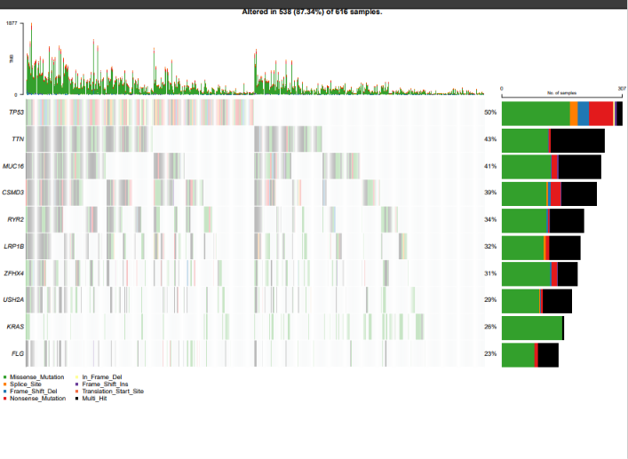
Figure 6.3.1: LUAD Oncoplot
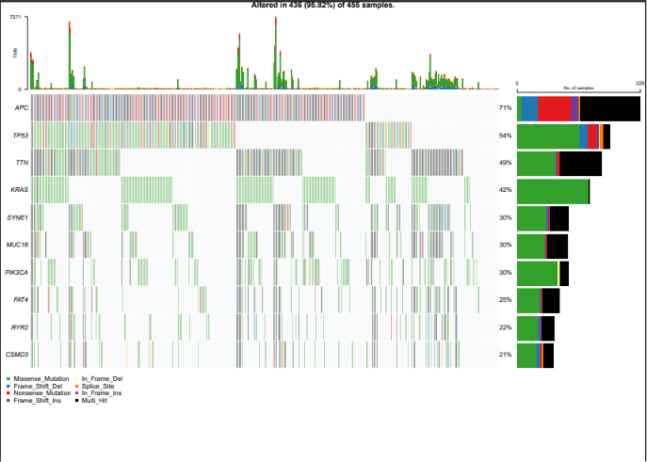
Figure 6.3.2: COAD Oncoplot

6.4 Comparative Mutation Analysis- Comparative mutation analysis. MafCompare function of the maftools package was used to perform comparative analysis on somatic mutation between LUAD and COAD. Statistical comparison on frequency of somatic mutation of genes between LUAD and COAD and identification of genes with mutations differences are also included. We listed some significantly mutated genes which had differences in mutation rate in LUAD and COAD including APC, PIK3CA, RNF43, FBXW7, SOX9 and KEAP1 etc. The results suggest LUAD and COAD are distinct types although they are also adenocarcinoma.
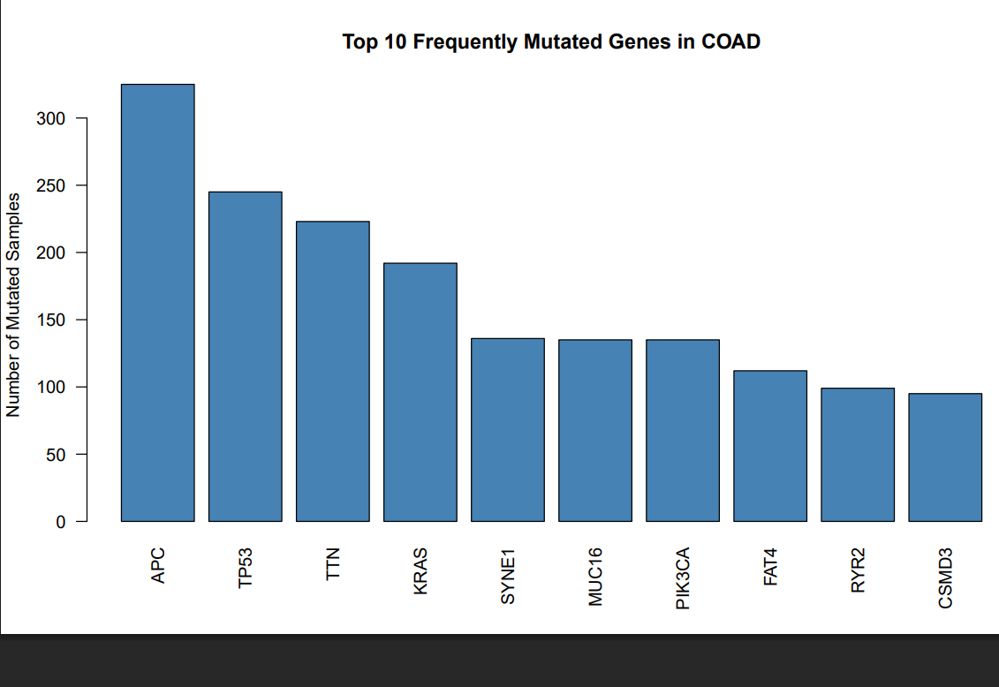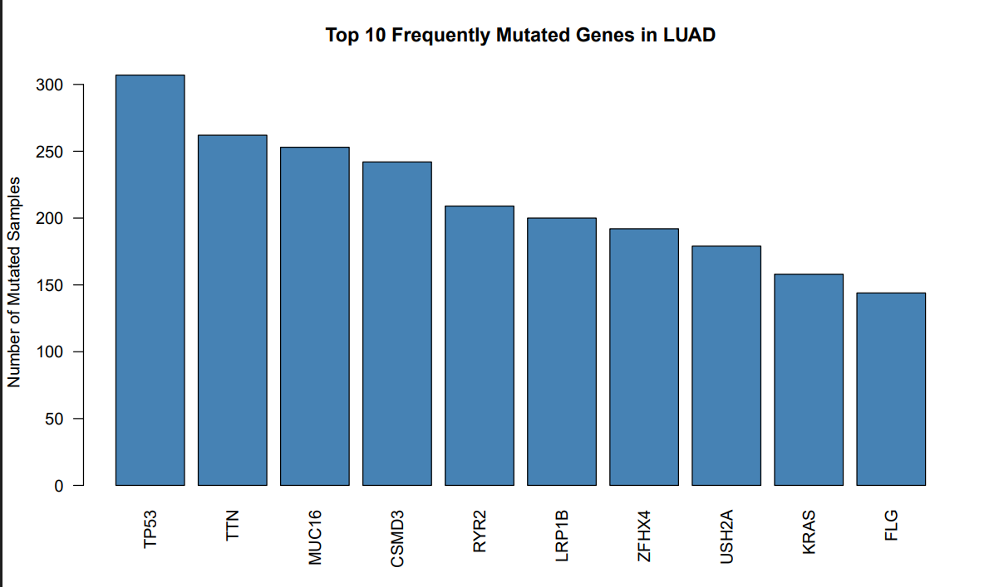
Figure 6.4.1: Frequently Mutated Genes in COAD and LAUD
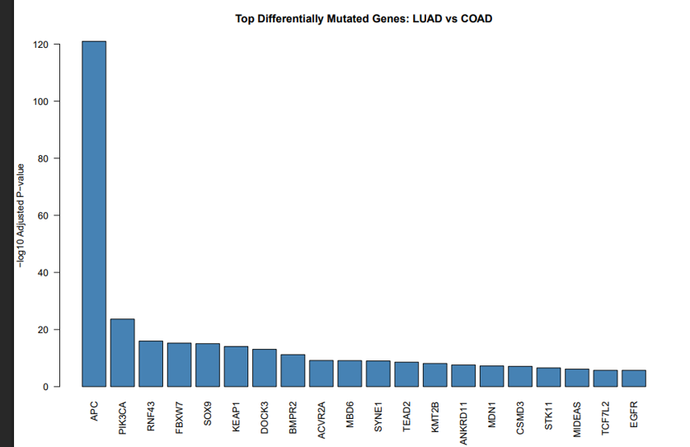
Figure 6.4.2: Top Differentially Mutated Genes

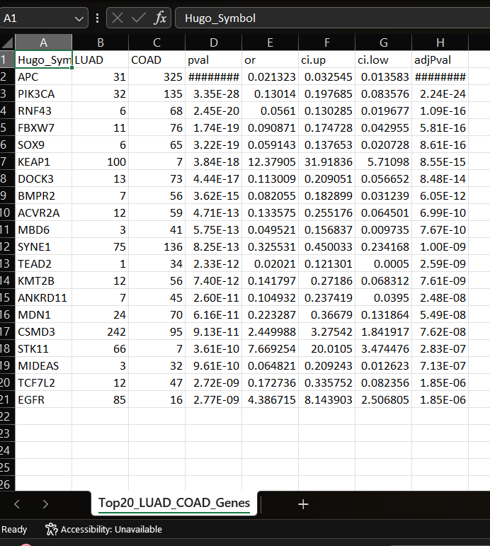
Table 6.4.3: Significant Differentially Mutated Genes
6.5 Mutational Signature Analysis- Comparative Mutation Analysis MafCompare function (maftools R package) was employed for comparative analysis on somatic mutation between LUAD and COAD. We performed the statistical analysis on the mutation frequencies of genes between LUAD and COAD genes with mutation difference between these two datasets was selected. We listed some top ranked genes which showed significantly different mutation frequencies between LUAD and COAD, such as APC, PIK3CA, RNF43, FBXW7, SOX9, KEAP1. The outcome suggests that LUAD and COAD belong to different groups despite they both are of adenocarcinoma type.
6.5.1 LAUD Mutational Signatures- The LAUD dataset showed major contributions from:
SBS4,SBS5, SBS2, SBS13
In samples where SBS4 was the prominent signature; it is well known to be derived from tobacco smoke SBS5 appeared in many samples, suggesting this to be a clock like mutational process related to the age of the donor SBS2 & SBS13 is associated with cytidine deamination caused by APOBEC (a common mechanism in lung cancer) All in all suggesting a good match with characteristics seen in lung adenocarcinoma
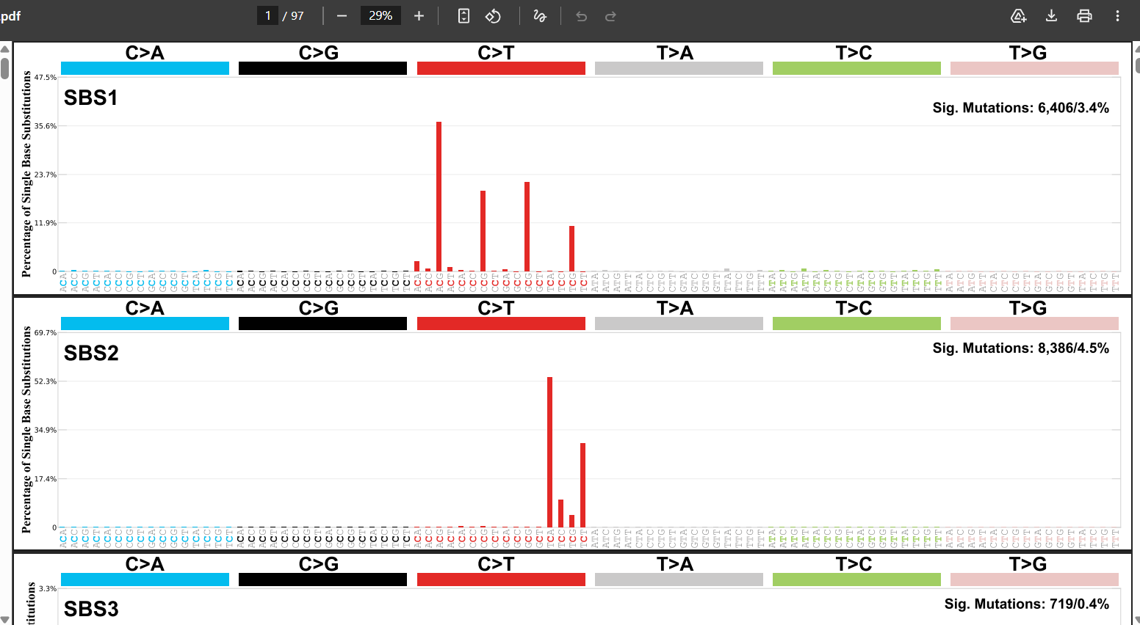
Figure 6.5.1a : LUAD SBS96 Signature Plot
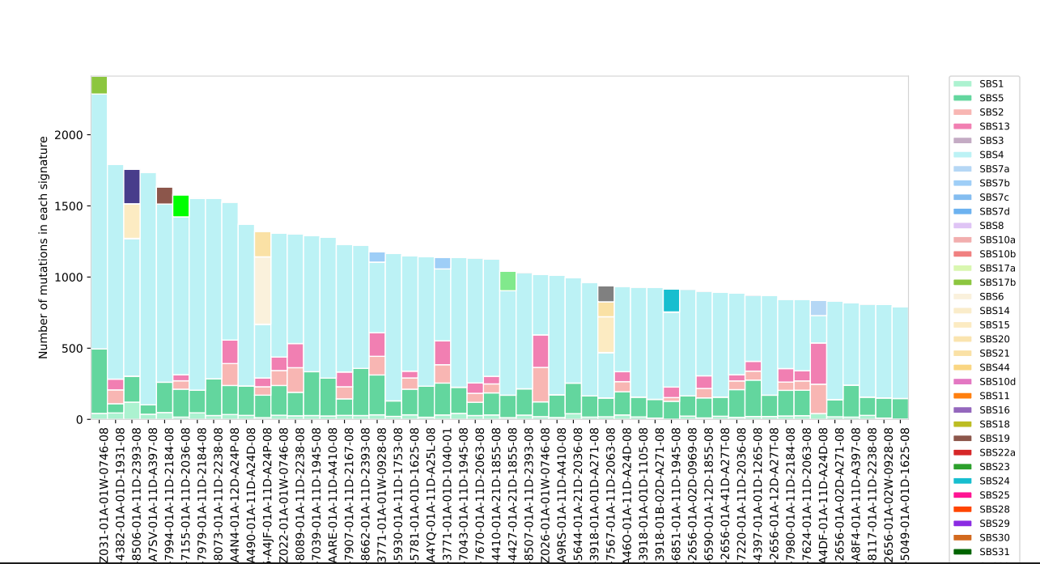
Figure 6.5.1.b: LUAD Signature Activity Plot

6.5.2 COAD Mutational Signatures- The COAD dataset demonstrated strong contribution from:
SBS10a, SBS10b, SBS15, SBS20, SBS21, SBS1,SBS5
SBS10a and SBS10b are indicative of proofreading deficiency arising from POLE mutations, which leads to ultra mutated colorectal tumours. SBS15, SBS20 and SBS21 have been previously identified as signs of mismatch repair deficiency and microsatellite instability, hallmarks of colorectal cancer. SBS1 and SBS5 which represents age-related signatures, were found to be present in a number of analysed samples. These results suggests that a significant part of the pathogenesis of COAD is related to errors in DNA repair processes.
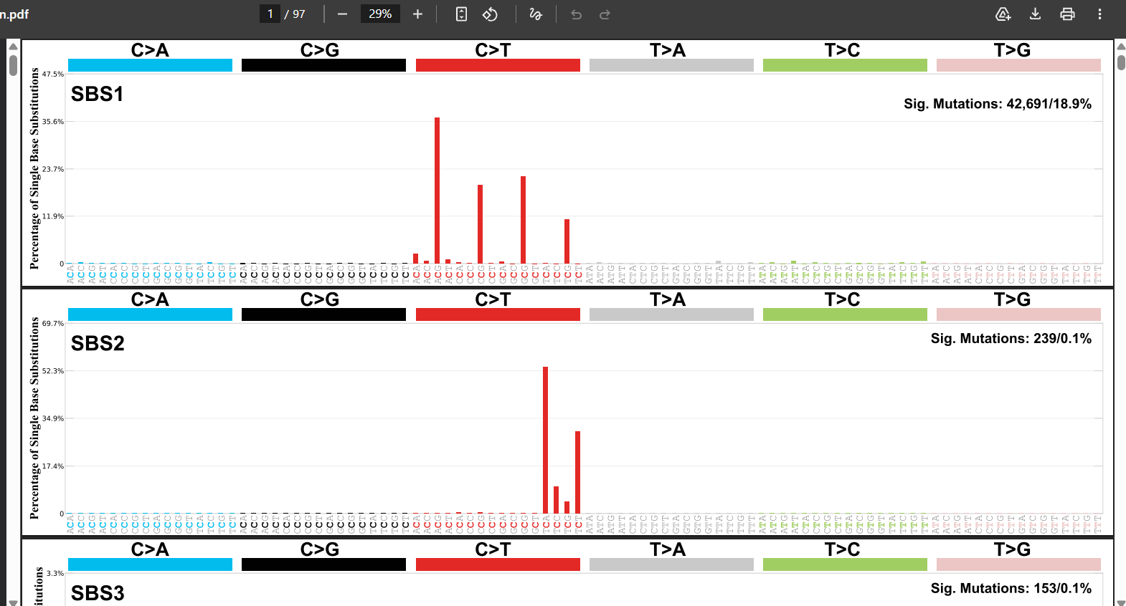
Figure 6.5.2.a: COAD SBS96 Signature Plot

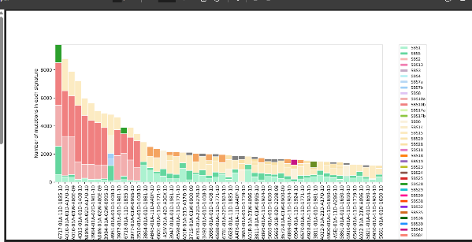
Figure 6.5.2.b: COAD Signature Activity Plot

6.6 Comparative Discussion- Our comparative analysis provided compelling evidence that the mutational landscapes of LUAD and COAD are quite distinct. Specifically, we highlighted the involvement of signature mutations resulting from the process of cigarette smoking and the APOBEC enzyme signature in LUAD, and the signatures that arose from defective mechanisms for DNA repair and deficiency in the DNA proofreading capacity of POLE in COAD. Comparison of mutational patterns uncovered distinct driver cancer gene patterns across the cancers, providing evidence for alternative molecular pathways that could drive tumorigenesis of these cancers.
Nevertheless, we observed the signatures of age-related mutational process includingSBS1 and SBS5 for both cancer types, implying cumulative intrinsic damage to DNA.
In summary, combining the information on mutation characteristics, comparative genomic data, and derived signatures provided deeper insights into the mechanistic aspects of cancer development, and confirmed the power of Bioinformatics tools in modern cancer genomics.

7. BIOLOGICAL INTERPRETATION
By characterising mutational profiles and mutational signatures, one is able to gather evidence relating to the mutational mechanisms which drive cancer Initiation and Progression. In this research, a detailed mutational profile for Lung Adenocarcinoma (LUAD) and Colon Adenocarcinoma (COAD) provided by TCGA were analysed in relation to the biological process that cause the development of tumours. By comparing the mutation frequencies of LUAD and COAD, some genes were observed to have different mutation profiles, such as APC, PIK3CA, RNF43, FBXW7, SOX9 and KEAP1.
These genes have a biological significance in a range of functions, for example, in cell signalling, the cell cycle, genome stability, as a tumour suppressor, and so forth.
This variation indicates that -LUAD and COAD follow different biological paths of development. The signatures identified in the two types of tumour provided insight into the biological process driving the mutagenesis. These Mutational signatures represent the characteristic patterns of genomic alterations occurring in each tumour and can be attributed to intrinsic processes within cells or external mutational factors. Mutational signatures found in the LUAD samples exhibited high levels of the SBS4 (associated with smoking-induced damage),SBS5 (clock-like mutational signature), SBS2 and SBS13 (APOBEC induced mutagenesis).
The presence of these signatures would imply the accumulation of somatic mutations due to tobacco smoking, age and also inherent APOBEC activity.
By comparison to LUAD, the COAD mutational signatures were more pronounced by SBS10a and SBS10b (associated with defects in DNA repair accuracy) signatures, indicating an ultramutated colorectal cancer population within this cohort. SBS15, SBS20, and SBS21 were also strong indicators of mismatch repair deficiency (MMRd) and microsatellite instability (MSI), a common molecular characteristic in colorectal cancer, whereby the lack of proper DNA repair pathways can allow errors to proliferate throughout the genome. Overall, by observing that the mutational signatures observed for LUAD and COAD both differed from those of SBS4, while there were strong indicators of MMR deficiency, a clear signature of colorectal cancer; there is sufficient evidence of diverse underlying genetic causes for cancer formation.

8. SKILLS GAINED
As part of the Genomics and Bioinformatics internship with BioTechTrek, I was exposed to various technical, professional and analytical skill building aspects using actual cancer genomics data, enhancing my knowledge of bioinformatics workflows, genomics and the biology of cancer genomics. Technical Skills Genomics and Bioinformatics I gained an understanding of cancer genomics and somatic mutations. Understanding mutation annotation format (MAF) files and how to perform analysis. Interpreting mutational signatures and utilizing the COSMIC database to obtain more biological context.
Comparative analysis of cancer datasets was performed. Analysis of the Tumor Mutation Burden (TMB). Biological interpretation of genomic data. Programming and Computational Skills I developed proficiency with R to apply the same to the various bioinformatic tasks. Understanding of large genomic data sets, data extraction, processing and manipulations.
Generation of mutation summary reports and various other statistics summaries. Visualization of various analysis of generated result. Bioinformatics Tools and Software maftools, SigProfilerAssignment R RStudio GitHub Microsoft Excel TCGA data portal COSMIC Database Data Visualization Skills Generation and visualization of oncoplots. Creation of mutation summaries visualization. Signature activity plot visualizations. Comparative mutation analysis of cancer cohorts. Tumor Mutation Burden visualization of cancer.
Research and Analytical Skills Literature review. Interpreting and using biological reasonings and insights in data. Comparative analysis of genomic datasets across different cancer types and platforms. Report generation and scientific documentation. Presentation of research outcomes.
Professional Skills Problem solving skills to overcome any technical issues. Critical and analytical thinking skills while interpreting and drawing insights. Time management skills to balance various analyses and tasks effectively. Independent learning of tools and concepts as needed to fulfil the task requirements. Research communication to peers and mentor. Documentation of data and procedures.

9. CHALLENGES FACED AND SOLUTIONS
While carrying out the project internship, there were certain problems encountered in dealing with such big cancer genomics datasets and in handling bioinformatic tools. In some cases, due to these problems, solutions had to be derived and this has developed the problem-solving and analysing skills in a lot more efficient way.
Table 9.1: Challenges and Solutions Implemented
Challenge Faced | Solution Implemented
Understanding the structure of TCGA Mutation Annotation Format (MAF) files | Studied TCGA documentation and explored sample datasets to understand the data format and mutation information.
Installation and configuration of bioinformatics tools | Followed official documentation and resolved package dependency issues through troubleshooting and online resources.
Handling large genomic datasets and output files | Organized files into separate folders and maintained a structured workflow for efficient data management.
Long execution time of computational analyses | Monitored system resources and executed analyses systematically to avoid interruptions and errors.
Interpretation of mutational signatures | Used the COSMIC Signature Database and scientific literature to understand the biological significance of identified signatures.
Comparing mutation profiles between LUAD and COAD | Generated mutation summaries, oncoplots, and comparative analyses to identify similarities and differences between the two cancer types.
Understanding the biological relevance of computational results | Conducted literature review and correlated findings with known cancer-associated genes and mutational processes.
Scientific report preparation and documentation | Maintained detailed records of workflows, outputs, and observations throughout the project.

Key Learning from Challenges
Addressing these difficulties built up my insight of cancer genomics work processes, Bioinformatics procedures, information administration, and Organic Interpretation. This experience enhanced my capacity to analyze my mistakes and boosted my certainty while dealing with a logical dataset derived from real data.

10. CONCLUSION
My Genomics and Bioinformatics Internship project involved analysing publicly available mutation data in The Cancer Genome Atlas (TCGA) and comparing mutation characteristics of two cancer types, Lung Adenocarcinoma (LUAD) and Colon Adenocarcinoma (COAD). I performed mutation summary analyses and generated comprehensive oncoplots presenting mutated genes in two cancer types; I also compared tumor mutation burden (TMB) plots for these two cancer types; furthermore, I generated and interpreted oncoplots, calculated mutation burden for these two cancer types and also profiled mutations by inferring the dominant mutational signatures of these two cancer types through a suite of tools(including maftools and custom R scripts). Our study was able to discover driver genes in LUAD and COAD; compared the gene mutation patterns; also showed a considerable difference in their mutational process signatures, thereby illustrating how molecular heterogeneity contributes to tumor progression, and how varied biological mechanisms can give rise to a cancer.
The internship helped me to have a broader understanding in the area of cancer genomics, genomic data analysis, mutational signatures, the process of interpretation of biological significances of the detected mutation, and scientific reports; at the same time, I was able to reinforce the following technical skills; in particular, skills with R programming language ,bioinformatics software, data visualization skills and how to document research.
In essence, the Genomics and Bioinformatics Internship learned in BioTechTrek helped me to effectively connect my theoretical knowledge with practical aspects and build solid foundations for further training and research in the fields bioinformatics, computational biology, bioinformatics, and personalized medicine.

11. REFERENCES
- Alexandrov, L. B., Kim, J., Haradhvala, N. J., Huang, M. N., Ng, A. W. T., Wu, Y., Boot, A., Covington, K. R., Gordenin, D. A., Bergstrom, E. N., Islam, S. M. A., Lopez-Bigas, N., Klimczak, L. J., McPherson, J. R., Morganella, S., Sabarinathan, R., Wheeler, D. A., Mustonen, V., Getz, G., & Stratton, M. R. (2020). The repertoire of mutational signatures in human cancer. Nature, 578(7793), 94–101. https://doi.org/10.1038/s41586-020-1943-3
- Cancer Genome Atlas Network. (2012). Comprehensive molecular characterization of human colon and rectal cancer. Nature, 487(7407), 330–337. https://doi.org/10.1038/nature11252
- Cancer Genome Atlas Research Network. (2014). Comprehensive molecular profiling of lung adenocarcinoma. Nature, 511(7511), 543–550. https://doi.org/10.1038/nature13385
- Forbes, S. A., Beare, D., Boutselakis, H., Bamford, S., Bindal, N., Tate, J., Cole, C. G., Ward, S., Dawson, E., Ponting, L., Stefancsik, R., Harsha, B., Kok, C. Y., Jia, M., Jubb, H., Sondka, Z., Thompson, S., De, T., & Campbell, P. J. (2017). COSMIC: Somatic cancer genetics at high-resolution. Nucleic Acids Research, 45(D1), D777–D783. https://doi.org/10.1093/nar/gkw1121
- Mayakonda, A., Lin, D. C., Assenov, Y., Plass, C., & Koeffler, H. P. (2018). Maftools: Efficient and comprehensive analysis of somatic variants in cancer. Genome Research, 28(11), 1747–1756. https://doi.org/10.1101/gr.239244.118
- Tate, J. G., Bamford, S., Jubb, H. C., Sondka, Z., Beare, D. M., Bindal, N., Boutselakis, H., Cole, C. G., Creatore, C., Dawson, E., Fish, P., Harsha, B., Hathaway, C., Jupe, S. C., Kok, C. Y., Noble, K., Ponting, L., Ramshaw, C. C., Rye, C. E., & Forbes, S. A. (2019). COSMIC: The Catalogue of Somatic Mutations in Cancer. Nucleic Acids Research, 47(D1), D941–D947. https://doi.org/10.1093/nar/gky1015
- Wang, S., Li, Y., Song, M., & Alexandrov, L. B. (2023). SigProfilerAssignment: Decomposition of mutational signatures in cancer genomes. Bioinformatics, 39(6), btad310. https://doi.org/10.1093/bioinformatics/btad310
- The Cancer Genome Atlas Program. (2025). The Cancer Genome Atlas (TCGA). National Cancer Institute. https://www.cancer.gov/tcga
- R Core Team. (2025). R: A language and environment for statistical computing. R Foundation for Statistical Computing. https://www.r-project.org/
- Bioconductor Project. (2025). Bioconductor: Open source software for bioinformatics. https://www.bioconductor.org/
- COSMIC Mutational Signatures. (2025). Catalogue of Somatic Mutations in Cancer (COSMIC). https://cancer.sanger.ac.uk/signatures/
- BioTechTrek. (2025). BioTechTrek – Bioinformatics and Biotechnology Training Platform. https://biotechtrek.in/
- National Cancer Institute. (2025). Cancer Genomics Overview. https://www.cancer.gov/about-cancer/causes-prevention/genetics
- National Human Genome Research Institute. (2025). Genomics and Precision Medicine. https://www.genome.gov/
- The Cancer Genome Atlas Research Network. (2013). The Cancer Genome Atlas pan-cancer analysis project. Nature Genetics, 45(10), 1113–1120. https://doi.org/10.1038/ng.2764

